# Surface unit user documentation

### General

- Main user is “drill” with password “raspberry”

- The terminal is opened by:

Start button (lower left corner) → System tools → LXTerminal

- Data-sheets and manuals for instruments, displays, etc. are located at

~/surface-unit/documentation

### Start-up script

- Launches automatically on startup (bash ~/drill-bootstrap.sh):

1. 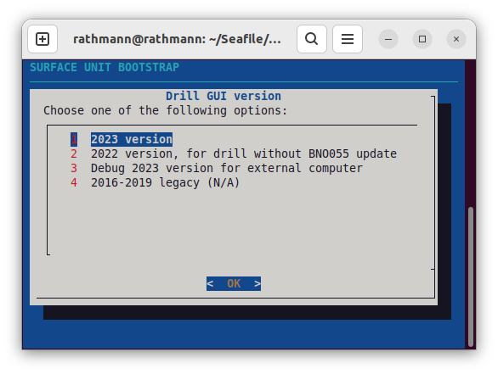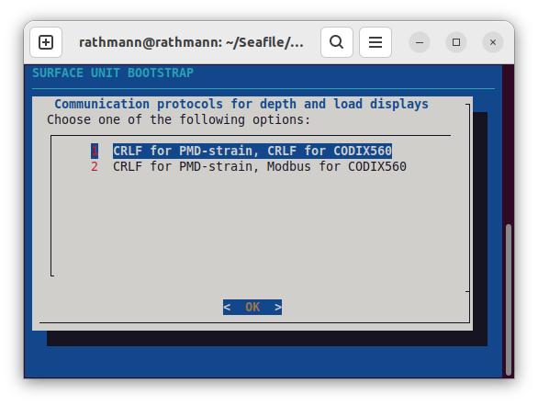- Sets static IP address to 10.2.3.10 (needed for EGRIP camp communication)
2. - Synchronizes wall clock (needed for log file timestamps)
3. - Launches scripts that communicate with the (1) load cell, (2) winch encoder (depth counter) , and (3) drill. All values are set in the local REDIS server.
4. - Launches drill control graphical software that interacts with drill through the REDIS server.

### Logs and drill plots

Logs are always backed up on the EGRIP “bob” server at:

10.2.3.1/public/drill-logs

Daily and sub-daily plots are generated automatically by “bob” and stored at:

10.2.3.1/public/drill-logs/plots

To plot daily logs yourself, run:

python3 ~/surface-unit/logging/plot-drill-log.py /mnt/logs/drill.log.YYYY-MM-DD HOUR_START HOUR_END /output/path

e.g.:

python3 ~/surface-unit/logging/plot-drill-log.py /mnt/logs/drill.log.2022-07-13 8 24 ./

### Scripts that are run on regular interval (crontab -e)

See crontab file for details; in short, it synchronizes the computer clock (if internet is available) and drill log with “bob” server at:

smb://10.2.3.1/public/drill-logs

### Software repository

All drill computer software (including logs plotting scripts) can be found at

https://github.com/nicholasmr/surface-unit

### If unable to resolve hostnames

Move “dns” forward (immediately after “myhostname”) in

/etc/nsswitch.conf

### How to calibrate depth counter

Full manual available at (see also page below)

~/surface-unit/documentation

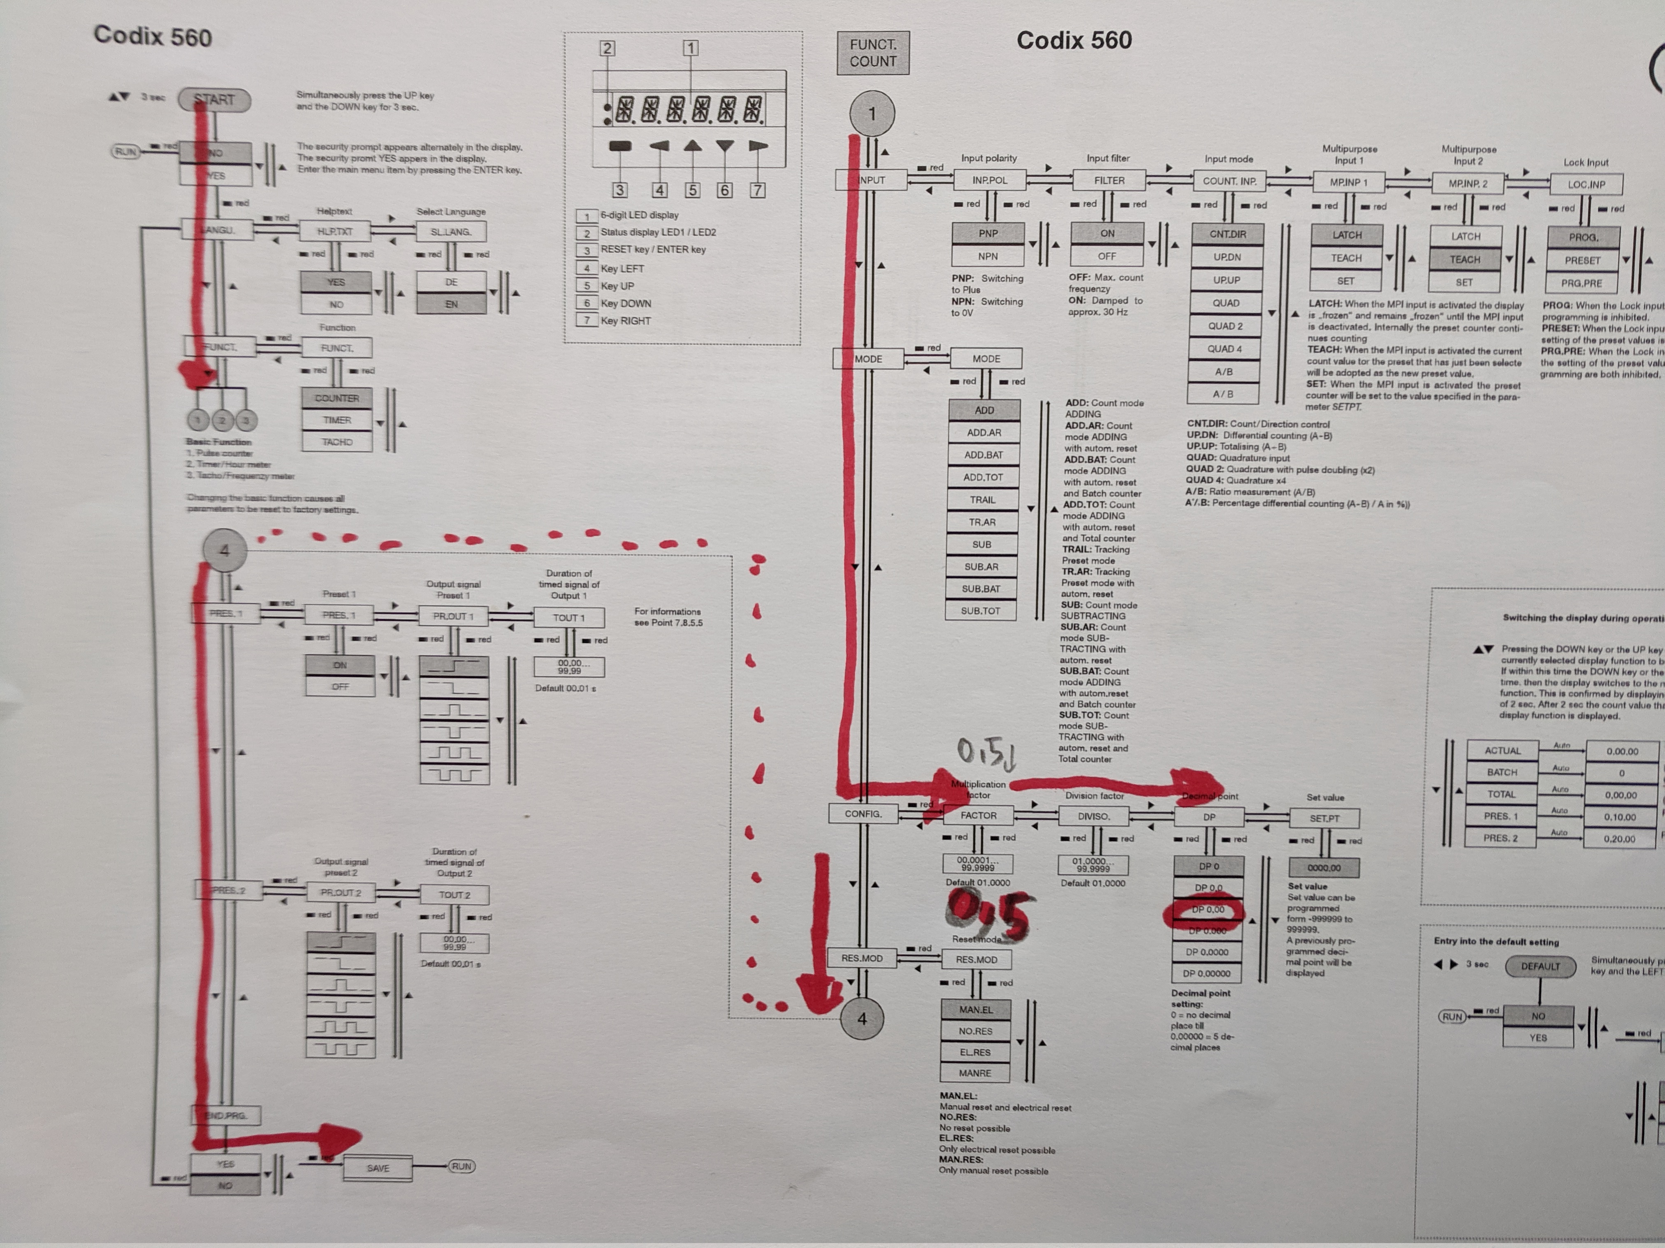

### Connections – what is what

